MAGNETIC BIOMATERIALS
BME 6164 Section: 3A20 Academic Term: Spring 2021
Class Periods: T Period 7 (1:55 PM - 2:45 PM) / Th Period 7-8 (1:55 PM - 3:50 PM)
Location: Online

Instructor:
Jon Dobson
Email:
jdobson@ufl.edu
Office Hours:
Zoom: By appointment
Teaching Assistants:
N/A

ZOOM COURSE LINK

https://ufl.zoom.us/j/92711154164 Meeting ID: 927 1115 4164

Course Description
This course will consist of classroom lectures on fundamental concepts in magnetism and magnetic micro- and nano-materials and their applications in biomedicine. As part of the course, students will present a critical review of recent literature in the field and lead a group discussion on a specific, recent paper.
Course Objectives:

- To provide the students with an overview of fundamental concepts in magnetism and magnetic materials.
- To present an overview of biomedical applications of both synthetic and endogenous magnetic micro- and nano-materials.
- To provide students with an understanding of critical evaluation of scientific literature and scientific and engineering research and development in this field, as well as the skills required to present and support their findings.

Course Prerequisites: PHY2048 & CHM2046
Textbook – None Required
Suggested Reading:

- The Feynman Lectures on Physics (Vol. 2), R. Feynman, Addison-Wesley. ISBN: 0-201-02117-X-P
- Magnetism: Principles & Applications, D. Craik, Wiley. ISBN: 0-471-95417-9
- Magnetic Nanoparticles: From Fabrication to Clinical Application, NTK Thanh (Ed.), CRC Press. ISBN: 978-1-4398-6932-1

Attendance Policy, Class Expectations, and Make-Up Policy
Attendance is not recorded. However, class notes will not be provided to absent students, unless they have excused absences. Excused absences are consistent with university policies in the undergraduate catalogue
(https://catalog.ufl.edu/ugrad/current/regulations/info/attendance.aspx (Links to an external site.)) and require appropriate documentation.
This course is, in part, a traditional lecture based course, and use of computers, tablets, and cell phones is distracting to your fellow classmates. Computers, tablets, and cell phones are not appropriate for use during this class and must be put away during class unless used for taking notes.
Unless prior arrangements or an excused absence has been granted by the instructor, students will be deducted 2 letter grades for late coursework (grading will start at 75% [C]). The deduction occurs at the time the work is due. Once the assignment has been handed back and the key discussed, a zero will be assigned late assignments that are not excused. Students with an excused absence shall be permitted a reasonable amount of time to make up the material or activities covered in their absence.
Evaluation of Grades

Assignment | Percentage of Final Grade
Exam #1 | 35%
Exam #2 | 35%
Literature Review | 30%
Grading Policy  A: 94-100 A-: 90-93 | B+: 87-89 B: 83-86 | B-: 80-82 | C+: 77-79
C: 73-76 C-: 70-72 | D+: 67-69 D: 63-66 | D-: 60-62 | E: <60

For information on current UF grading policies for assigning grade points, please
visit: https://catalog.ufl.edu/ugrad/current/regulations/info/grades.aspx (Links to an external site.).

A C- will not be a qualifying grade for critical tracking courses. In order to graduate, students must have an overall GPA and an upper-division GPA of 2.0 or better (C or better). Note: A C- average is equivalent to a GPA of 1.67, and therefore, it does not satisfy this graduation requirement. More information on UF grading policy may be found
at: https://catalog.ufl.edu/ugrad/current/regulations/info/grades.aspx (Links to an external site.).

TENTATIVE Course Schedule
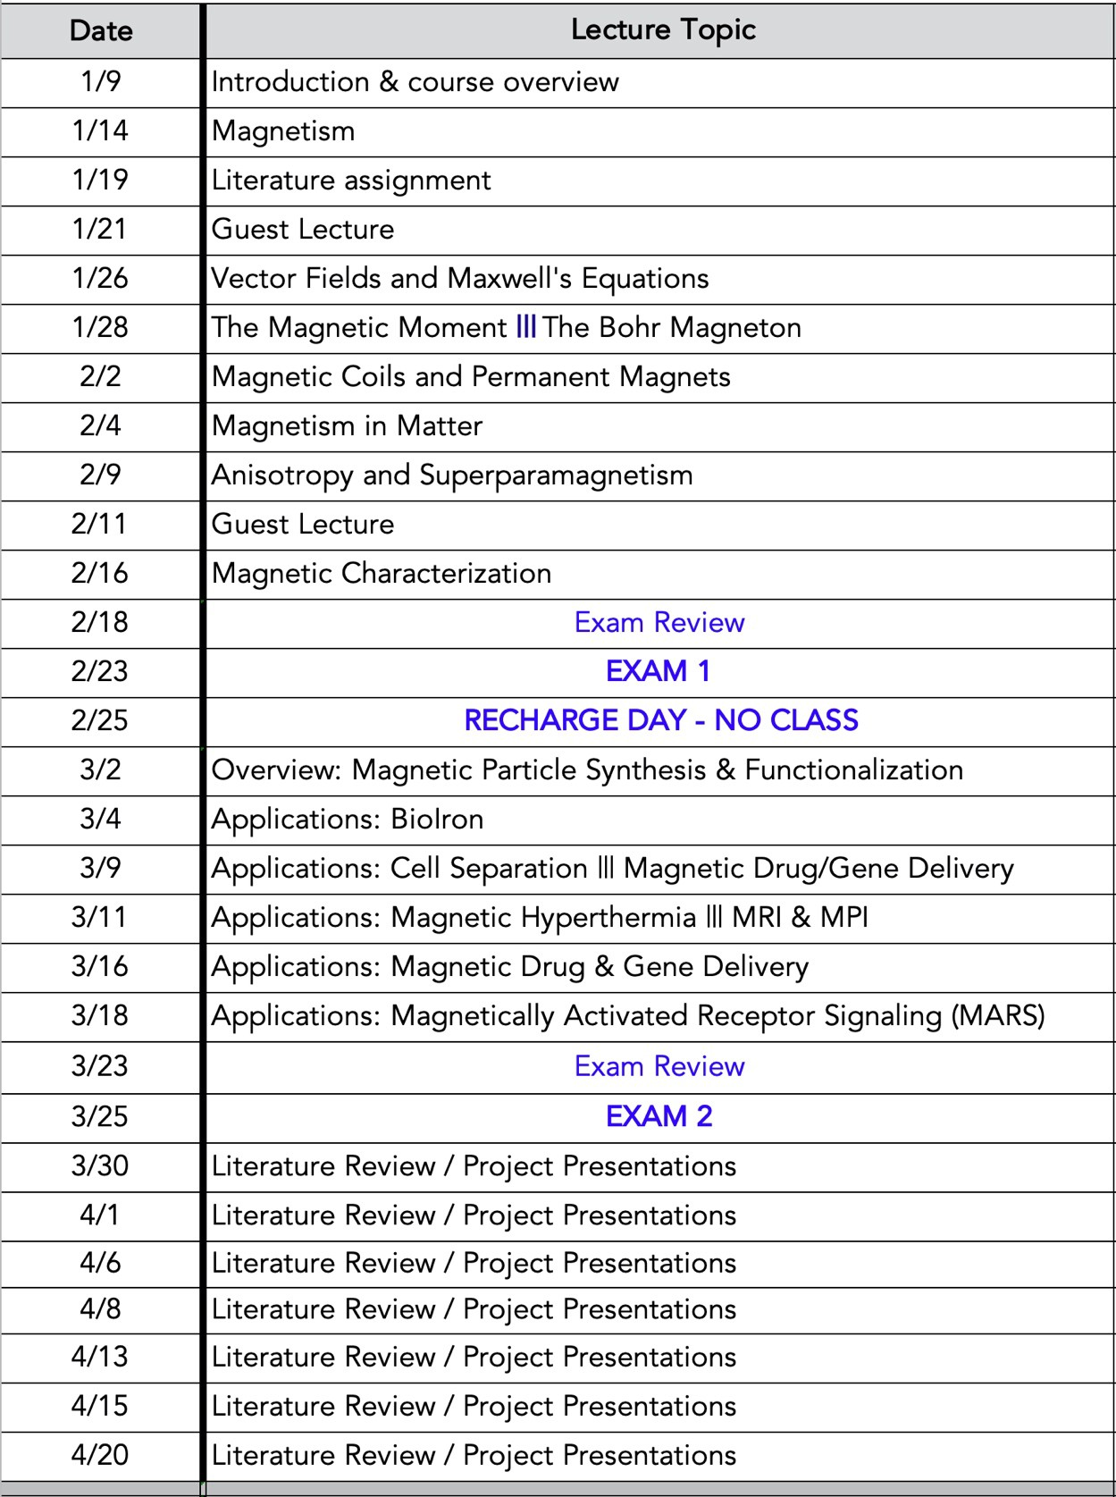

Students Requiring Accommodations
Students with disabilities requesting accommodations should first register with the Disability Resource Center (352-392-8565, https://www.dso.ufl.edu/drc) by providing appropriate documentation. Once registered, students will receive an accommodation letter which must be presented to the instructor when requesting accommodation. Students with disabilities should follow this procedure as early as possible in the semester.
Course Evaluation
Students are expected to provide feedback on the quality of instruction in this course by completing online evaluations at https://evaluations.ufl.edu/evals (Links to an external
site.). Evaluations are typically open during the last two or three weeks of the semester, but students will be given specific times when they are open. Summary results of these assessments are available to students at https://evaluations.ufl.edu/results/ (Links to an external site.).
University Honesty Policy
UF students are bound by The Honor Pledge which states, “We, the members of the University of Florida community, pledge to hold ourselves and our peers to the highest standards of honor and integrity by abiding by the Honor Code. On all work submitted for credit by students at the University of Florida, the following pledge is either required or implied: “On my honor, I have neither given nor received unauthorized aid in doing this assignment.” The Honor Code (https://www.dso.ufl.edu/sccr/process/student-conduct-honor-code/) specifies a number of behaviors that are in violation of this code and the possible sanctions. Furthermore, you are obligated to report any condition that facilitates academic misconduct to appropriate personnel. If you have any questions or concerns, please consult with the instructor or TAs in this class.
Software Use
All faculty, staff, and students of the University are required and expected to obey the laws and legal agreements governing software use. Failure to do so can lead to monetary damages and/or criminal penalties for the individual violator. Because such violations are also against University policies and rules, disciplinary action will be taken as appropriate. We, the members of the University of Florida community, pledge to uphold ourselves and our peers to the highest standards of honesty and integrity.
Student Privacy
There are federal laws protecting your privacy with regards to grades earned in courses and on individual assignments. For more information, please see:
http://registrar.ufl.edu/catalog0910/policies/regulationferpa.html (Links to an external site.)
Plagiarism

Plagiarism is a common infraction to the UF Honor Code. If you are confused as to what constitutes plagiarism, see here: https://guides.uflib.ufl.edu/copyright/plagiarism (Links to an external site.).
Plagiarism on any of your assignments will be reported to the Dean of Students as a UF Student

Honor Code violation. Also, note that copying solutions for any assignment, regardless of the source (e.g. other students, pirated website solutions), will be treated as plagiarism. If you have any questions or concerns, please consult with the instructor in this class. Note that failure to comply with this commitment will result in disciplinary action compliant with the UF Student Honor Code Procedures.

Campus Resources:
Health and Wellness
U Matter, We Care:
At UF Every Gator Counts. U Matter, We Care serves as UF’s umbrella program for UF’s caring culture and provides students in distress with support and coordination of the wide variety of appropriate resources. Families, faculty and students can contact umatter@ufl.edu seven days a week for assistance for students in distress. If you or a friend is in distress, please
contact umatter@ufl.edu or 352 392-1575 so that a team member can reach out to the student.
Counseling and Wellness Center: The counseling and wellness center provides resources for students in distress, including but not limited to suicide prevent, crisis management, advice on parenting a college student, and advice on adjusting to college
life. http://www.counseling.ufl.edu/cwc (Links to an external site.), and 392-1575; and the University Police Department: 392-1111 or 9-1-1 for emergencies.
Sexual Assault Recovery Services (SARS): Sexual assault recovery services are available in the Student Health Care Center, contact at 392-1161.
University Police Department provides security and police services to the University of
Florida. Contact at392-1111 (or 9-1-1 for emergencies), or http://www.police.ufl.edu/ (Links to an external site.).
Academic Resources
E-learning technical support: Technical support for the Universities e-learning websites is available. Contact at 352-392-4357 (select option 2) or e-mail to Learning-
support@ufl.edu. https://lss.at.ufl.edu/help.shtml (Links to an external site.).
Career Resource Center: Whether it’s connecting dots to figure out your interests or finding ways to connect with opportunities, the University of Florida Career Resource Center (CRC) is here to help you figure it out. The CRC focuses on your interests and experiences – not just your major.
They can help you make sense of where you’ve been and show you where you can go. Reitz Union, 392-1601. Career assistance and counseling. https://www.crc.ufl.edu/ (Links to an external site.).

Library Support: Librarians are available to help you identify resources related to this course material. Contact at http://cms.uflib.ufl.edu/ask (Links to an external site.) for various ways to receive assistance with respect to using the libraries or finding resources.

Teaching Center: The mission of the Teaching Center at the University of Florida is to empower students to become successful lifelong learners. Through a variety of services and instructional approaches, the Teaching Center seeks to help students master effective ways of learning for different disciplines, Broward Hall, 392-2010 or 392-6420. General study skills and
tutoring. https://teachingcenter.ufl.edu/ (Links to an external site.).

Writing Studio, 302 Tigert Hall, 846-1138. The writing studio provides help brainstorming, formatting, and writing papers. https://writing.ufl.edu/writing-studio/ (Links to an external site.).
Student Complaints Campus: The University of Florida believes strongly in the ability of students to express concerns regarding their experiences at the University. The University encourages its students who wish to file a written complaint to submit that complaint directly to the department that manages that policy. Information available
at https://www.dso.ufl.edu/documents/UF_Complaints_policy.pdf (Links to an external site.) and http://www.distance.ufl.edu/student-complaint-process (Links to an external site.).
Commitment to a safe and inclusive learning environment

The Herbert Wertheim College of Engineering values broad diversity within our community and is committed to individual and group empowerment, inclusion, and the elimination of discrimination.
It is expected that every person in this class will treat one another with dignity and respect regardless of gender, sexuality, disability, age, socioeconomic status, ethnicity, race, and culture.
If you feel like your performance in class is being impacted by discrimination or harassment of any kind please contact your instructor or any of the following:

- Your academic advisor or Graduate Program Coordinator
- Robin Bielling, Director of Human Resources, 352-392-0903, rbielling@eng.ufl.edu
- Curtis Taylor, Associate Dean of Student Affairs, 352-392-2177, taylor@eng.ufl.edu
- Toshikazu Nishida, Associate Dean of Academic Affairs, 352-392-0943, nishida@ufl.edu

Sexual Discrimination, Harassment, Assault, or Violence
If you or a friend has been subjected to sexual discrimination, sexual harassment, sexual assault, or violence contact the Office of Title IX Compliance, located at Yon Hall Room 427, 1908 Stadium Road, (352) 273-1094, title-ix@ufl.edu

